Narrative Unit Notes KEY
Complete this for
the story we read
as a class
Title of story (underline it or use italics):
Author of story:
Genre:

the turning point; the pivotal moment that changes the outcome, usually the most dramatic, often a decision/action that leads to a solution or conflict resolution

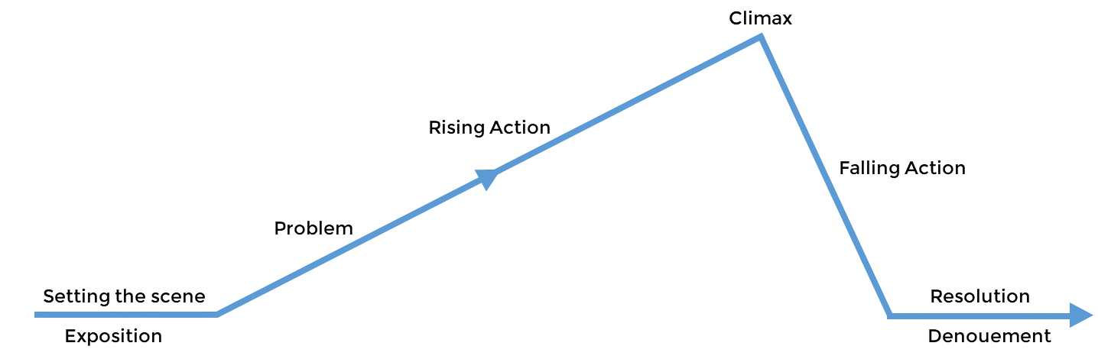

List 1-2 events that occur as a result of the climax
list 3-5 MAIN events that are vital to the plot

how did the story end?
- Hook (which strategy?):
- What information was revealed?):
  - Characters
  - Relevant context & backstory
  - Setting
  - Conflict (protagonist’s goal & obstacle)

Study the dialogue. What do you notice about HOW TO WRITE DIALOGUE?

  - New paragraph each time someone speaks
  - Each paragraph is indented
  - Once you have established which characters are speaking, you do not need to repeat which characters are speaking unless it is unclear
  - Use better words (more specific) than “said”
  - Use quotation marks
  - Punctuation for what’s said goes inside the quotation marks.
  - Capitalize the beginning of each sentence
  - Use single quotes if the person speaking is quoting someone.

Write down as many examples of FIGURATIVE LANGUAGE from the story as you find.
Complete this for
the story we read
as a class
Complete this for
the story we read
as a class

Example | Type of figurative language | Page #

Complete this for
the story we read
as a class
Complete this for
the story we read
as a class
Choose a CHARACTER from this story and record as much as you can about him/her:
age, appearance, goals, friends, family, preferences, dislikes, obstacles/enemies, personality,
etc. You can do this by drawing/sketching or with words (list, paragraph). Use the space below.

R.2 - determine central ideas, themes, supporting details, and summarize.
*This shows up as R.1 in Powerschool.*
Complete this for
the story we read
as a class
Complete this for
the story we read
as a class

- What are some key words to describe this story? In other words, this story is about
__________________, __________________________, and ________________________.
- Now choose one of those key words that you feel best represents the story and/or can be supported with the most examples/proof from the text. Circle it above.
- What lesson is the author trying to teach about this topic OR what lesson does a character learn about this topic? This is the theme! Think of this as the moral. Write the theme here:

- Find an example from the beginning of the story that serves as evidence of this theme. For example, if your theme is “Family is more important than anything,” then find an event or line of dialogue that illustrates this in the beginning of the text. Use either a direct citation (quotation marks) or paraphrase but be sure to explain what is happening and how it relates to the theme AND include the page number(s).

- Find an example (event or line of dialogue) from the middle of the story that serves as evidence of this theme. Use either a direct citation (quotation marks) or paraphrase but be sure to explain what is happening and how it relates to the theme AND include the page number(s).

- Find an example (event or line of dialogue) from the end of the story that serves as evidence of this theme. Use either a direct citation (quotation marks) or paraphrase but be sure to explain what is happening and how it relates to the theme AND include the page number(s).

- Summarize the story by completing the following using important events:
SOMEBODY | WANTED | BUT | SO | THEN

R.3 - Analyze how particular lines of dialogue/story events propel action, reveal
Complete this for
the story we read
as a class
Complete this for
the story we read
as a class
character aspects of a character, or provoke a decision. *Note the impact
of one line of dialogue or event on actions (plot), decisions, and characters. *

- Identify an event that moved the story along (at any point). Explain the event and how
it propelled the action.

- Think about the character you chose to analyze/describe.
  - Which event revealed something new about this character (personality, goals, strengths, behaviors, etc.)?
_____________________________________________________________________________________ Explain.

  - Look at what you wrote/drew for him/her. Choose one thing about him/her and find a piece of dialogue from the story that illustrates/underscores/reveals/highlights this information. For example, if the character is very intelligent, find dialogue (people speaking) about how intelligent he/she is. Be sure to write the dialogue like this: “’blah blah’” (Crutcher pg.#). OR “’blah blah’” (Crutcher 33).

  - Which event or dialogue caused this character (or someone else) to make an important decision? _______________
_____________________________________________________________________________________. Explain.

Narrative Unit Notes Student name: ______________________________
Title of story (underline it or use italics):
Complete this for
the story we read
as a class
Author of story:
Genre:

the turning point; the pivotal moment that changes the outcome, usually the most dramatic, often a decision/action that leads to a solution or conflict resolution

List 1-2 events that occur as a result of the climax
list 3-5 MAIN events that are vital to the plot

how did the story end?
- Hook (which strategy?):
- What information was revealed?):
  - Characters
  - Relevant context & backstory
  - Setting
  - Conflict (protagonist’s goal & obstacle)

Study the dialogue. What do you notice about HOW TO WRITE DIALOGUE?

  - New ____________________ each time ______________________ _____________
  - Each paragraph is _____________________
  - Once you have established which characters are speaking, you do not need to repeat…… unless…
  - Use better words (more specific) than __________
  - Use ___________________________ ________________
  - Punctuation for what’s said goes _______________________ the quotation marks.
  - ________________________ the beginning of each sentence
  - Use ________________________ _________________ if the person speaking is quoting someone.

Complete this for
the story we read
as a class
Write down as many examples of FIGURATIVE LANGUAGE from the story as you find.
See the last pages of this packet for help identifying examples of figurative language
and/or vocabulary notes.

Example | Type of figurative language | Page #

Complete this for
the story we read
as a class
Choose a CHARACTER from this story and record as much as you can about him/her:
age, appearance, goals, friends, family, preferences, dislikes, obstacles/enemies, personality,
etc. You can do this by drawing/sketching or with words (list, paragraph). Use the space below.

R.2 - determine central ideas, themes, supporting details, and summarize.
*This shows up as R.1 in Powerschool.*
Complete this for
the story we read
as a class

- What are some key words to describe this story? In other words, this story is about
__________________, __________________________, and ________________________.
- Now choose one of those key words that you feel best represents the story and/or can be supported with the most examples/proof from the text. Circle it above.
- What lesson is the author trying to teach about this topic OR what lesson does a character learn about this topic? This is the theme! Think of this as the moral. Write the theme here:

- Find an example from the beginning of the story that serves as evidence of this theme. For example, if your theme is “Family is more important than anything,” then find an event or line of dialogue that illustrates this in the beginning of the text. Use either a direct citation (quotation marks) or paraphrase but be sure to explain what is happening and how it relates to the theme AND include the page number(s).

- Find an example (event or line of dialogue) from the middle of the story that serves as evidence of this theme. Use either a direct citation (quotation marks) or paraphrase but be sure to explain what is happening and how it relates to the theme AND include the page number(s).

- Find an example (event or line of dialogue) from the end of the story that serves as evidence of this theme. Use either a direct citation (quotation marks) or paraphrase but be sure to explain what is happening and how it relates to the theme AND include the page number(s).

- Summarize the story by completing the following using important events:
SOMEBODY | WANTED | BUT | SO | THEN

R.3 - Analyze how particular lines of dialogue/story events propel action, reveal
Complete this for
the story we read
as a class
character aspects of a character, or provoke a decision. *Note the impact
of one line of dialogue or event on actions (plot), decisions, and characters. *

- Identify an event that moved the story along (at any point). Explain the event and how
it propelled the action.

- Think about the character you chose to analyze/describe.
  - Which event revealed something new about this character (personality, goals, strengths, behaviors, etc.)?
_____________________________________________________________________________________ Explain.

  - Look at what you wrote/drew for him/her. Choose one thing about him/her and find a piece of dialogue from the story that illustrates/underscores/reveals/highlights this information. For example, if the character is very intelligent, find dialogue (people speaking) about how intelligent he/she is. Be sure to write the dialogue like this: “’blah blah’” (Crutcher pg.#). OR “’blah blah’” (Crutcher 33).

  - Which event or dialogue caused this character (or someone else) to make an important decision? _______________
_____________________________________________________________________________________. Explain.

Narrative Unit Notes
Complete this
for the story
you chose
Title of story (underline it or use italics):
Author of story:
Genre:

the turning point; the pivotal moment that changes the outcome, usually the most dramatic, often a decision/action that leads to a solution or conflict resolution

List 1-2 events that occur as a result of the climax
list 3-5 MAIN events that are vital to the plot

how did the story end?
- Hook (which strategy?):
- What information was revealed?):
  - Characters
  - Relevant context & backstory
  - Setting
  - Conflict (protagonist’s goal & obstacle)

Study the dialogue. What do you notice about HOW TO WRITE DIALOGUE?

  - New ____________________ each time ______________________ _____________
  - Each paragraph is _____________________
  - Once you have established which characters are speaking, you do not need to repeat…… unless…
  - Use better words (more specific) than __________
  - Use ___________________________ ________________
  - Punctuation for what’s said goes _______________________ the quotation marks.
  - ________________________ the beginning of each sentence
  - Use ________________________ _________________ if the person speaking is quoting someone.

Complete this
for the story
you chose
Write down as many examples of FIGURATIVE LANGUAGE from the story as you find.
See the last pages of this packet for help identifying examples of figurative language
and/or vocabulary notes.

Example | Type of figurative language | Page #

Complete this
for the story
you chose
Choose a CHARACTER from this story and record as much as you can about him/her:
age, appearance, goals, friends, family, preferences, dislikes, obstacles/enemies, personality,
etc. You can do this by drawing/sketching or with words (list, paragraph). Use the space below.

R.2 - determine central ideas, themes, supporting details, and summarize.
*This shows up as R.1 in Powerschool.*
Complete this
for the story
you chose

- What are some key words to describe this story? In other words, this story is about
__________________, __________________________, and ________________________.
- Now choose one of those key words that you feel best represents the story and/or can be supported with the most examples/proof from the text. Circle it above.
- What lesson is the author trying to teach about this topic OR what lesson does a character learn about this topic? This is the theme! Think of this as the moral. Write the theme here:

- Find an example from the beginning of the story that serves as evidence of this theme. For example, if your theme is “Family is more important than anything,” then find an event or line of dialogue that illustrates this in the beginning of the text. Use either a direct citation (quotation marks) or paraphrase but be sure to explain what is happening and how it relates to the theme AND include the page number(s).

- Find an example (event or line of dialogue) from the middle of the story that serves as evidence of this theme. Use either a direct citation (quotation marks) or paraphrase but be sure to explain what is happening and how it relates to the theme AND include the page number(s).

- Find an example (event or line of dialogue) from the end of the story that serves as evidence of this theme. Use either a direct citation (quotation marks) or paraphrase but be sure to explain what is happening and how it relates to the theme AND include the page number(s).

- Summarize the story by completing the following using important events:
SOMEBODY | WANTED | BUT | SO | THEN

R.3 - Analyze how particular lines of dialogue/story events propel action, reveal
Complete this
for the story
you chose
character aspects of a character, or provoke a decision. *Note the impact
of one line of dialogue or event on actions (plot), decisions, and characters. *

- Identify an event that moved the story along (at any point). Explain the event and how
it propelled the action.

- Think about the character you chose to analyze/describe.
  - Which event revealed something new about this character (personality, goals, strengths, behaviors, etc.)?
_____________________________________________________________________________________ Explain.

  - Look at what you wrote/drew for him/her. Choose one thing about him/her and find a piece of dialogue from the story that illustrates/underscores/reveals/highlights this information. For example, if the character is very intelligent, find dialogue (people speaking) about how intelligent he/she is. Be sure to write the dialogue like this: “’blah blah’” (Crutcher pg.#). OR “’blah blah’” (Crutcher 33).

  - Which event or dialogue caused this character (or someone else) to make an important decision? _______________
_____________________________________________________________________________________. Explain.

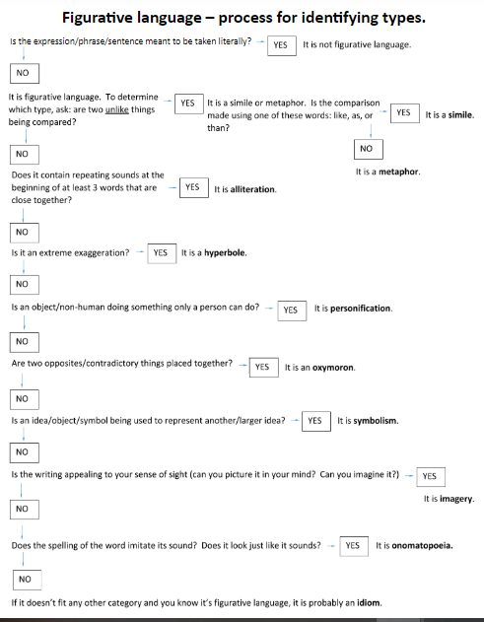

VOCABULARY - For this unit, you need to understand the following vocabulary terms so that you can apply them to texts while completing literary analysis. You may use this page to take notes (write definitions/descriptions, draw pictures/visual clues, or write helpful hints). Please note that you can find Quizlet sets for most of these terms, and we will practice in class. There is an extra space in case you/we encounter a term that needs added.

Protagonist | Antagonist | Conflict (know the different types from last year)
Introduction (exposition) | Rising action | Climax | Resolution
Setting (when & where) | Falling action | Main idea-v-supporting detail | Theme
Dialogue | Static character | Dynamic character | Narrative
Textual evidence | Summary | Figurative language
Types of figurative language
Simile | Metaphor | Hyperbole | Personification
Onomatopoeia | Alliteration | Oxymoron | Symbolism
Idiom | Imagery | Allusion

