The Outsiders Review
NAME __________________________________

Character Matching (one character is used twice & one isn’t used at all)

Cherry Valance Sandy Darry Curtis Two-Bit Matthews Johnny Cade Curly Shepard
Sodapop Curtis Steve Randall Ponyboy Curtis Dallas “Dally” Winston Randy Adderson Paul Holden
Bob Sheldon Jerry Wood Tim Shepard Mr. Syme Buck Merrill Marcia

- _________________is the heavy-set man who tries to rescue kids from the burning church, but couldn’t fit. He goes to the
hospital with Ponyboy after the church fire.

- _________________is the oldest of his brothers (he raises them). He dropped out of school and is tough on Ponyboy.

- _________________is the Soc who wears heavy rings and severely beats up Johnny.

- ________________ dropped out of school and works as a mechanic. He’s attractive and gets along well with Ponyboy.

- _________________is the youngest of the Greaser gang. He likes to watch movies alone.

- _________________is the toughest Greaser who used to live in New York. He helps Ponyboy and Johnny run away.

- _________________is the Soc who tries to make peace with Ponyboy after the church fire.

- _________________is Dally’s rodeo friend who opens the door when Johnny and Ponyboy seek help after the Soc death.

- _________________is Soda’s best friend who doesn’t like Ponyboy always hanging around.

- _________________has alcoholic, abusive parents and is very quiet. He dies after being burned and injured in the church fire.

- _________________is known for being funny and a shoplifter.

- _________________ is the Soc who is stabbed to death and dates Cherry Valance.

- _________________is Ponyboy’s Soc friend who becomes a spy before the big rumble toward the end of the novel.

- _________________is the leader of another Greaser gang. He is friends with Dally (they both like the rodeo).

- _________________is the girl Soda wants to marry.

- _________________is the teacher who assigns an essay to Ponyboy so that he will pass.

17. Go back to the list of characters and highlight all of the dynamic characters. The rest are static.

18. Who is the protagonist? _____________________How do you know? Use the definition AND something specific from the novel.

19. Who/what is the antagonist? __________________How do you know? Use the definition AND something specific from the novel.

20. List 3 supporting/minor characters.

21. Who is the narrator? ____________________ How do you know?

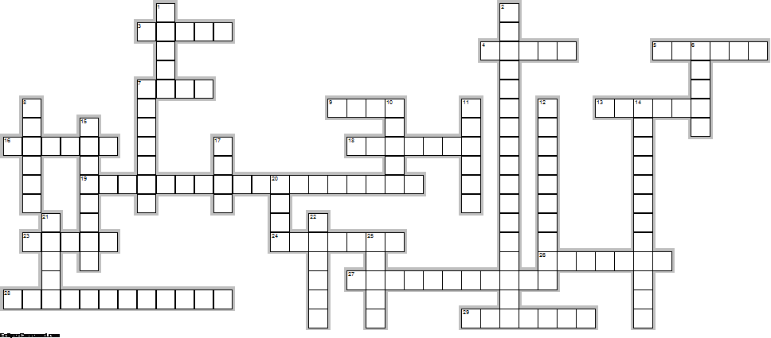
The Outsiders – Crossword Review: Answers with more than one word have a space in between each word.

Across
3. He is the biggest delinquent of the Greasers (has been in the most trouble), but truly cares about his friends
4. This Soc visits Ponyboy at home and wishes things would change between Socs and Greasers.
5. Cherry and Ponyboy realize that both Socs and Greasers can see this even though they live in very different places; perhaps they're not so different after all
7. Mr. _____ is Ponyboy's English teacher who plays an important role at the end of the novel.
9. Johnny tells Ponyboy to stay ____, which means to stay pure, special, and see the good in the world.
13. This is what a fight is called between the Socs and Greasers
16. She has fiery red hair and spies for the Greasers even though she is a Soc
18. This is the funniest Greaser.
19. This is the book Ponyboy reads to Johnny while at the church; he requests this book while in the hospital.
23. Cherry threw this in Dally's face at the movies.
24. Sandy moves to this state
26. Ponyboy's middle brother who dropped out of school, works at a gas station, and is always happy
27. This is the main character of the story who solves the main conflict.
28. Johnny and Ponyboy stayed in a church in this city when they hid from the police
29. A type of character who changes (internally) by the end of a story
Down
1. This is Soda's girlfriend
2. This genre contains elements that are fake, but could be true (or are inspired by true events)
6. This type of genre contains more than one conflict, more than 15,000 words, and is always fiction.
7. This is how old the author was when she wrote The Outsiders.
8. The "pet" of the Greasers whose parents beat/neglect him. He kills Bob.
10. During the fight in chapter four, the Socs try to ____ Ponyboy, which is why Johnny kills Bob.
11. Toward the end of the novel, Ponyboy breaks a ____ and uses it to threaten the Socs.
12. This is the person/thing/group that causes the main conflicts.
14. This is the name of the horse that Sodapop used to "own"
15. One of the reasons Sandy leaves is because she is _____.
17. Ponyboy first runs away from home because Darry ____ him.
20. Slang for "area"
21. This is how Ponyboy and Johnny get to the abandoned church.
22. Johnny refuses to see his ____ when he's in the hospital.
25. Ponyboy's oldest brother
Conflicts - For the following events, identify which type of conflict is portrayed.

- To save Pony from being drowned, Johnny stabs Bob. Man-v-_________________________

- When Pony and Johnny run away from the crime, they face being hunted down by the police. Man-v-____________

- Johnny tries to look tough in front of the Socs, but there is panic in his eyes and he is white with fear. Man-v-___________

- Ponyboy tries to stay warm in the cold evening air. Man-v-_________________________

- Pony feels bitter because the Socs enjoy a rich, easy life. Man-v-_________________________

- Darry is so angry with Ponyboy for staying out late that he slaps him. Man-v-_________________________

- Pony and Johnny fight their sleepiness as they climb the hill to the church. Man-v-_________________________

Story Map - Fill out the story map for The Outsiders.
CLIMAX / TURNING POINT

RISING ACTION EVENTS
1. _______________________________
_______________________________

2. _______________________________
_______________________________

3. _______________________________
_______________________________

4. _______________________________
_______________________________

5. _______________________________
_______________________________

Major conflict:
_______________________________

_______________________________

Type of conflict: man-v-___________

FALLING ACTION EVENTS
1. _______________________________

_______________________________

2. _______________________________

_______________________________

FALLING ACTION

RISING ACTION

RESOLUTION
HOW WAS PROBLEM SOLVED? HOW DOES STORY END?

EXPOSITION / INTRODUCTION
SETTING (when & where) CHARACTERS (list 10)

Figurative Language – View the following examples and answer questions about each one.
- “Johnny Cade reminded me of a lost puppy who had been kicked too many times.”
  - What type of figurative language is used?

  - Is anything being compared? _______ If so, what?

  - What is the literal translation? In other words, what does the author really mean?

  - Does this…
    - Reveal the inspiration behind the actor chosen to play Johnny in the movie?
    - Reveal the author’s perception of Johnny’s home life?
    - Reveal the narrator’s perception of Johnny’s personality and appearance?
    - Suggest that Johnny is dirty?

- “But most [Socs] looked at us as if we were dirt.”
  - What type of figurative language is used?

  - Is anything being compared? _______ If so, what?

  - What is the literal translation? In other words, what does the author really mean?

  - Does this…
    - Help the reader understand the relationship between Socs and Greasers?
    - Emphasize the Socs ability to do well in school?
    - Explain why Socs hate Greasers?
    - Suggest that Ponyboy and Cherry will become friends?

Grammar – Fix the following “sentences” using professional spelling, capitalization, grammar, and punctuation and answer questions about each one.
- But Darry never got over it, and every once in a while
- She was a smart girl she didn’t like him just because he was good-looking
- A reckless, hot-tempered boy, cocky and scared stiff at the same time

KNOW FOR THE TEST (in addition to the information in this review packet):
- Identify themes
- Understand author’s purpose, information, etc.
- Know the definitions of genres and prove that they apply to this story
- Identify differences between the movie and novel

